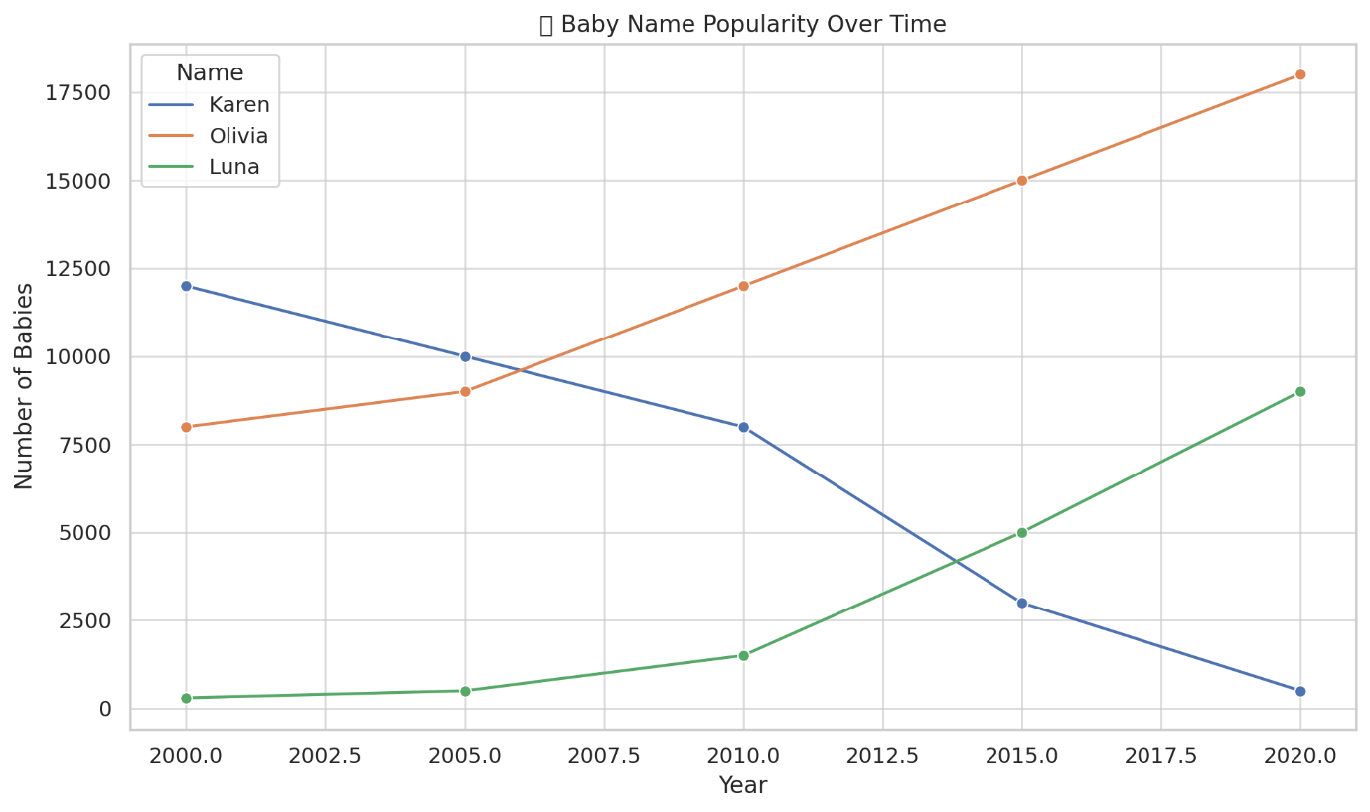

**Chart Caption:**

**"Karen's Decline, Luna's Rise: Baby Name Trends from 2000 to 2020"**  
Once a top pick, *Karen* has plummeted in popularity, likely due to cultural memes. Meanwhile, *Olivia* remains a timeless favorite, and *Luna*—perhaps thanks to Harry Potter and celestial vibes—has seen a stellar rise in recent years.

import pandas as pd

import matplotlib.pyplot as plt

import seaborn as sns

# Fun/weird dataset: Top baby names over time (sample)

data = pd.DataFrame({

'Year': [2000, 2005, 2010, 2015, 2020],

'Karen': [12000, 10000, 8000, 3000, 500],

'Olivia': [8000, 9000, 12000, 15000, 18000],

'Luna': [300, 500, 1500, 5000, 9000]

})

# Melt the DataFrame for seaborn

melted_data = data.melt(id_vars='Year', var_name='Name', value_name='Count')

# Plot

plt.figure(figsize=(10, 6))

sns.lineplot(data=melted_data, x='Year', y='Count', hue='Name', marker='o')

plt.title("🍼 Baby Name Popularity Over Time")

plt.xlabel("Year")

plt.ylabel("Number of Babies")

plt.grid(True)

plt.tight_layout()

plt.show()